| PHASE 2: INNOVATION   ajay nm.jpg A. Water Level Sensors WhatsApp Image 2023-10-11 at 11.46.17 AM.jpeg  B. Communication Modules |
| --- |

Water Level Sensors:

Water level sensors are crucial to prevent the fountain from running dry. They ensure that there is a sufficient amount of water in the fountain, preventing damage to the pump or other components. This is vital for the fountain's proper functioning and longevity

Communication Modules:

Communication modules such as Wi-Fi or Bluetooth are essential for enabling connectivity. They allow the fountain to communicate with other devices or systems, facilitating remote monitoring and control. With these modules, the fountain can be integrated into IoT networks, enabling real-time data analysis and decision-making processes. Remote monitoring also allows for timely maintenance and ensures uninterrupted operation.

STEP FOR FLOW CHART:

Start: The program begins.

Initialize System: Initialize the IoT device, including the water level sensor and communication module.

Read Water Level: Read data from the water level sensor to determine the current water level in the fountain.

Check Water Level:

If water level is below a certain threshold:

Turn on the water pump to refill the fountain.

Wait for the water level to rise.

If water level is normal:

Continue to the next step.

User Interaction:

Check for user input or commands via the communication module.

If there are user commands:

Execute the corresponding action (e.g., change fountain pattern, adjust water flow, etc.).

If there are no user commands:

Continue to the next step.

Update Status:

Send status updates (water level, system health, etc.) to a remote server or user interface using the communication module.

Check System Health:

Monitor the overall health of the system, including sensor functionality and communication module.

If there are issues:

Send an alert/notification to the user or system administrator.

Attempt to resolve the issue (restart system, reset sensors, etc.).

End: The program ends, or it loops back to the start, depending on the system requirements.

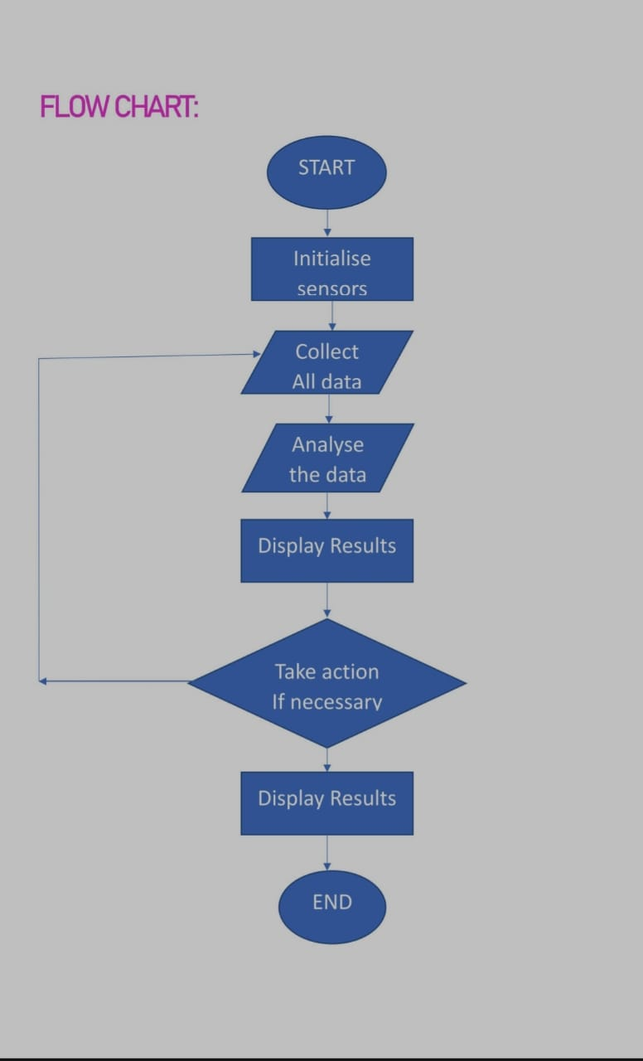

Analyse the data

Display result

Take a action if necessary

Display the result

Collect all data

Initialise sensor